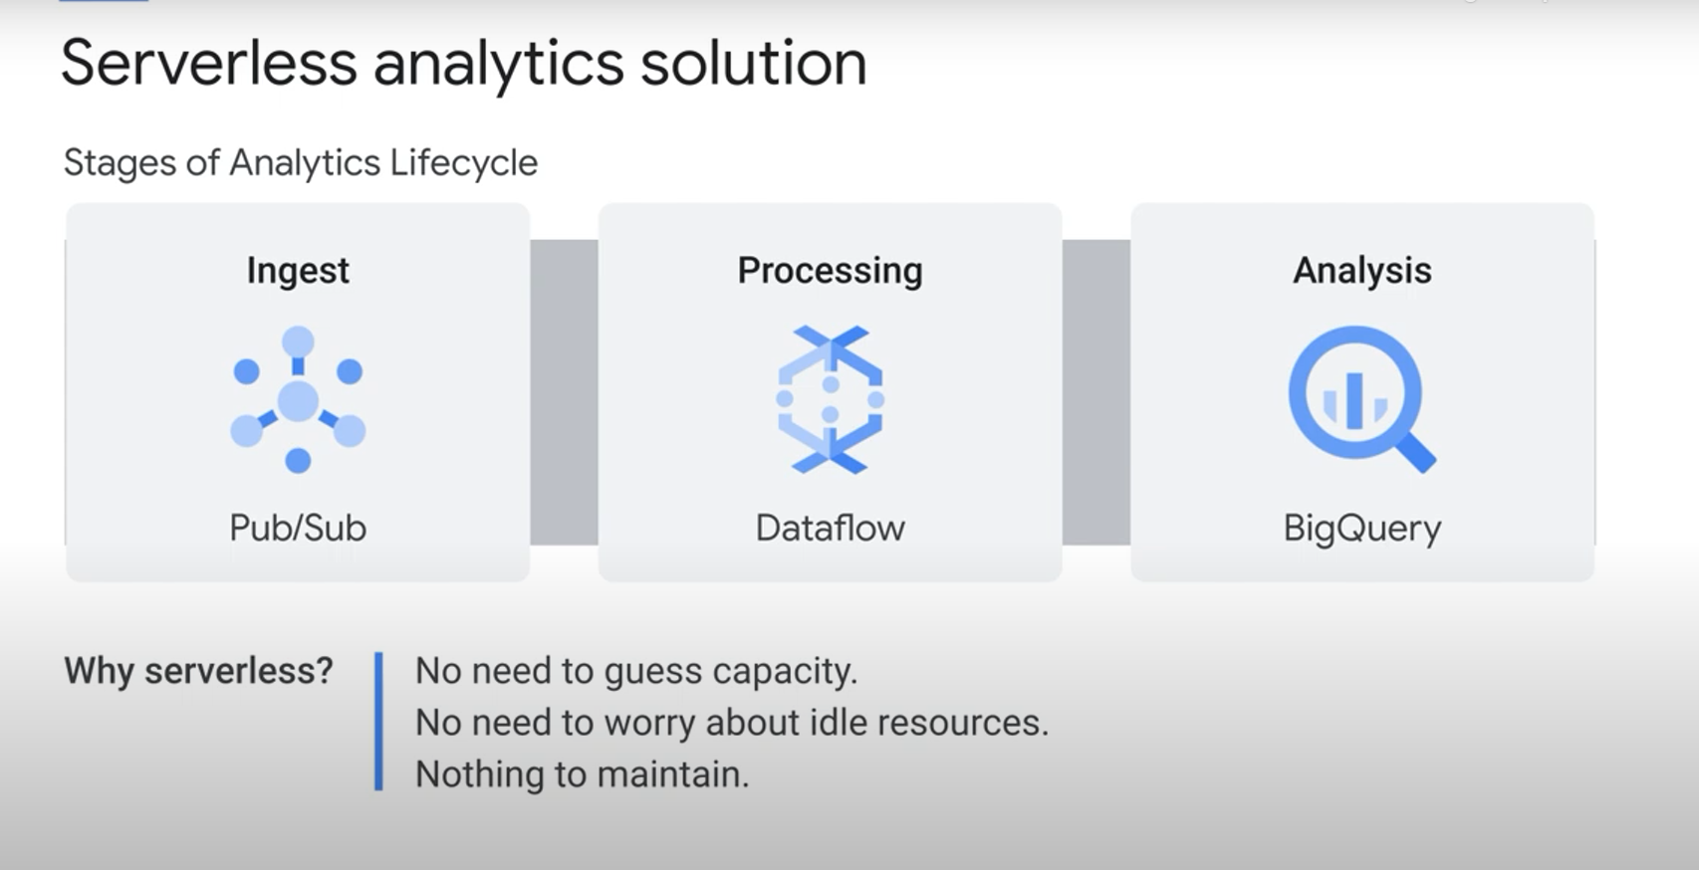

Real-life Example:

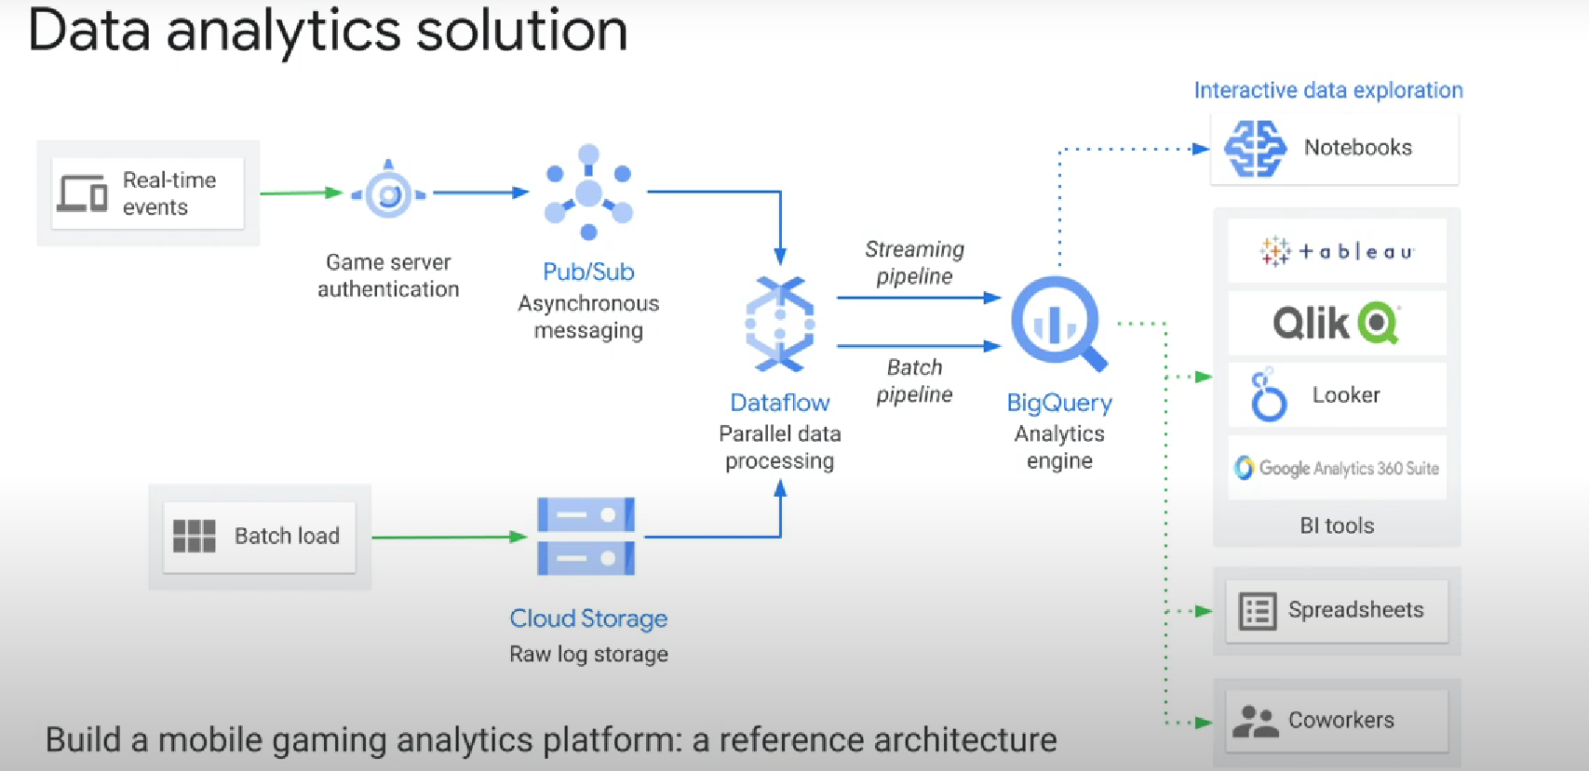

For ML: **Spark ML** (creating the model) + **Dataproc** PySpark job, to invoke Spark ML functions

+ **Apache Spark**, to access the resulting linear regression table + **BigQuery**, to prepare the linear regression input table, which is written to your Google Cloud project